**Chapter 8. Joins**

[Chapter 7](https://www.safaribooksonline.com/library/view/spark-the-definitive/9781491912201/ch07.html#s2c4---aggregations) covered aggregating single datasets, which is helpful, but more often than not, your Spark applications are going to bring together a large number of different datasets. For this reason, joins are an essential part of nearly all Spark workloads. Spark’s ability to talk to different data means that you gain the ability to tap into a variety of data sources across your company. This chapter covers not just what joins exist in Spark and how to use them, but some of the basic internals so that you can think about how Spark actually goes about executing the join on the cluster. This basic knowledge can help you avoid running out of memory and tackle problems that you could not solve before.

**Join Expressions**

A *join* brings together two sets of data, the *left* and the *right*, by comparing the value of one or more *keys* of the left and right and evaluating the result of a *join expression* that determines whether Spark should bring together the left set of data with the right set of data. The most common join expression, an equi-join, compares whether the specified keys in your left and right datasets are equal. If they are equal, Spark will combine the left and right datasets. The opposite is true for keys that do not match; Spark discards the rows that do not have matching keys. Spark also allows for much more sophsticated join policies in addition to equi-joins. We can even use complex types and perform something like checking whether a key exists within an array when you perform a join.

**Join Types**

Whereas the join expression determines whether two rows *should* join, the join type determines *what* should be in the result set. There are a variety of different join types available in Spark for you to use:

* Inner joins (keep rows with keys that exist in the left and right datasets)
* Outer joins (keep rows with keys in either the left or right datasets)
* Left outer joins (keep rows with keys in the left dataset)
* Right outer joins (keep rows with keys in the right dataset)
* Left semi joins (keep the rows in the left, and only the left, dataset where the key appears in the right dataset)
* Left anti joins (keep the rows in the left, and only the left, dataset where they do not appear in the right dataset)
* Natural joins (perform a join by implicitly matching the columns between the two datasets with the same names)
* Cross (or Cartesian) joins (match every row in the left dataset with every row in the right dataset)

If you have ever interacted with a relational database system, or even an Excel spreadsheet, the concept of joining different datasets together should not be too abstract. Let’s move on to showing examples of each join type. This will make it easy to understand exactly how you can apply these to your own problems. To do this, let’s create some simple datasets that we can use in our examples:

*// in Scala*

**val** person **=** **Seq**(

(0, "Bill Chambers", 0, **Seq**(100)),

(1, "Matei Zaharia", 1, **Seq**(500, 250, 100)),

(2, "Michael Armbrust", 1, **Seq**(250, 100)))

.toDF("id", "name", "graduate_program", "spark_status")

**val** graduateProgram **=** **Seq**(

(0, "Masters", "School of Information", "UC Berkeley"),

(2, "Masters", "EECS", "UC Berkeley"),

(1, "Ph.D.", "EECS", "UC Berkeley"))

.toDF("id", "degree", "department", "school")

**val** sparkStatus **=** **Seq**(

(500, "Vice President"),

(250, "PMC Member"),

(100, "Contributor"))

.toDF("id", "status")

*# in Python*

person = spark.createDataFrame([

(0, "Bill Chambers", 0, [100]),

(1, "Matei Zaharia", 1, [500, 250, 100]),

(2, "Michael Armbrust", 1, [250, 100])])\

.toDF("id", "name", "graduate_program", "spark_status")

graduateProgram = spark.createDataFrame([

(0, "Masters", "School of Information", "UC Berkeley"),

(2, "Masters", "EECS", "UC Berkeley"),

(1, "Ph.D.", "EECS", "UC Berkeley")])\

.toDF("id", "degree", "department", "school")

sparkStatus = spark.createDataFrame([

(500, "Vice President"),

(250, "PMC Member"),

(100, "Contributor")])\

.toDF("id", "status")

Next, let’s register these as tables so that we use them throughout the chapter:

person.createOrReplaceTempView("person")

graduateProgram.createOrReplaceTempView("graduateProgram")

sparkStatus.createOrReplaceTempView("sparkStatus")

**Inner Joins**

Inner joins evaluate the keys in both of the DataFrames or tables and include (and join together) only the rows that evaluate to true. In the following example, we join the graduateProgram DataFrame with the person DataFrame to create a new DataFrame:

*// in Scala*

**val** joinExpression **=** person.col("graduate_program") === graduateProgram.col("id")

*# in Python*

joinExpression = person["graduate_program"] == graduateProgram['id']

Keys that do not exist in both DataFrames will not show in the resulting DataFrame. For example, the following expression would result in zero values in the resulting DataFrame:

*// in Scala*

**val** wrongJoinExpression **=** person.col("name") === graduateProgram.col("school")

*# in Python*

wrongJoinExpression = person["name"] == graduateProgram["school"]

Inner joins are the default join, so we just need to specify our left DataFrame and join the right in the JOIN expression:

person.join(graduateProgram, joinExpression).show()

*-- in SQL*

**SELECT** * **FROM** person **JOIN** graduateProgram

**ON** person.graduate_program = graduateProgram.id

+---+----------------+----------------+---------------+---+-------+----------+---

| id| name|graduate_program| spark_status| id| degree|department|...

+---+----------------+----------------+---------------+---+-------+----------+---

| 0| Bill Chambers| 0| [100]| 0|Masters| School...|...

| 1| Matei Zaharia| 1|[500, 250, 100]| 1| Ph.D.| EECS|...

| 2|Michael Armbrust| 1| [250, 100]| 1| Ph.D.| EECS|...

+---+----------------+----------------+---------------+---+-------+----------+---

We can also specify this explicitly by passing in a third parameter, the joinType:

*// in Scala*

**var** joinType **=** "inner"

*# in Python*

joinType = "inner"

person.join(graduateProgram, joinExpression, joinType).show()

*-- in SQL*

**SELECT** * **FROM** person **INNER** **JOIN** graduateProgram

**ON** person.graduate_program = graduateProgram.id

+---+----------------+----------------+---------------+---+-------+--------------

| id| name|graduate_program| spark_status| id| degree| department...

+---+----------------+----------------+---------------+---+-------+--------------

| 0| Bill Chambers| 0| [100]| 0|Masters| School...

| 1| Matei Zaharia| 1|[500, 250, 100]| 1| Ph.D.| EECS...

| 2|Michael Armbrust| 1| [250, 100]| 1| Ph.D.| EECS...

+---+----------------+----------------+---------------+---+-------+--------------

**Outer Joins**

Outer joins evaluate the keys in both of the DataFrames or tables and includes (and joins together) the rows that evaluate to true or false. If there is no equivalent row in either the left or right DataFrame, Spark will insert null:

joinType **=** "outer"

person.join(graduateProgram, joinExpression, joinType).show()

*-- in SQL*

**SELECT** * **FROM** person **FULL** **OUTER** **JOIN** graduateProgram

**ON** graduate_program = graduateProgram.id

+----+----------------+----------------+---------------+---+-------+-------------

| id| name|graduate_program| spark_status| id| degree| departmen...

+----+----------------+----------------+---------------+---+-------+-------------

| 1| Matei Zaharia| 1|[500, 250, 100]| 1| Ph.D.| EEC...

| 2|Michael Armbrust| 1| [250, 100]| 1| Ph.D.| EEC...

|null| null| null| null| 2|Masters| EEC...

| 0| Bill Chambers| 0| [100]| 0|Masters| School...

+----+----------------+----------------+---------------+---+-------+-------------

**Left Outer Joins**

Left outer joins evaluate the keys in both of the DataFrames or tables and includes all rows from the left DataFrame as well as any rows in the right DataFrame that have a match in the left DataFrame. If there is no equivalent row in the right DataFrame, Spark will insert null:

joinType **=** "left_outer"

graduateProgram.join(person, joinExpression, joinType).show()

*-- in SQL*

**SELECT** * **FROM** graduateProgram **LEFT** **OUTER** **JOIN** person

**ON** person.graduate_program = graduateProgram.id

+---+-------+----------+-----------+----+----------------+----------------+---

| id| degree|department| school| id| name|graduate_program|...

+---+-------+----------+-----------+----+----------------+----------------+---

| 0|Masters| School...|UC Berkeley| 0| Bill Chambers| 0|...

| 2|Masters| EECS|UC Berkeley|null| null| null|...

| 1| Ph.D.| EECS|UC Berkeley| 2|Michael Armbrust| 1|...

| 1| Ph.D.| EECS|UC Berkeley| 1| Matei Zaharia| 1|...

+---+-------+----------+-----------+----+----------------+----------------+---

**Right Outer Joins**

Right outer joins evaluate the keys in both of the DataFrames or tables and includes all rows from the right DataFrame as well as any rows in the left DataFrame that have a match in the right DataFrame. If there is no equivalent row in the left DataFrame, Spark will insert null:

joinType **=** "right_outer"

person.join(graduateProgram, joinExpression, joinType).show()

*-- in SQL*

**SELECT** * **FROM** person **RIGHT** **OUTER** **JOIN** graduateProgram

**ON** person.graduate_program = graduateProgram.id

+----+----------------+----------------+---------------+---+-------+------------+

| id| name|graduate_program| spark_status| id| degree| department|

+----+----------------+----------------+---------------+---+-------+------------+

| 0| Bill Chambers| 0| [100]| 0|Masters|School of...|

|null| null| null| null| 2|Masters| EECS|

| 2|Michael Armbrust| 1| [250, 100]| 1| Ph.D.| EECS|

| 1| Matei Zaharia| 1|[500, 250, 100]| 1| Ph.D.| EECS|

+----+----------------+----------------+---------------+---+-------+------------+

**Left Semi Joins**

Semi joins are a bit of a departure from the other joins. They do not actually include any values from the right DataFrame. They only compare values to see if the value exists in the second DataFrame. If the value does exist, those rows will be kept in the result, even if there are duplicate keys in the left DataFrame. Think of left semi joins as filters on a DataFrame, as opposed to the function of a conventional join:

joinType **=** "left_semi"

graduateProgram.join(person, joinExpression, joinType).show()

+---+-------+--------------------+-----------+

| id| degree| department| school|

+---+-------+--------------------+-----------+

| 0|Masters|School of Informa...|UC Berkeley|

| 1| Ph.D.| EECS|UC Berkeley|

+---+-------+--------------------+-----------+

*// in Scala*

**val** gradProgram2 **=** graduateProgram.union(**Seq**(

(0, "Masters", "Duplicated Row", "Duplicated School")).toDF())

gradProgram2.createOrReplaceTempView("gradProgram2")

*# in Python*

gradProgram2 = graduateProgram.union(spark.createDataFrame([

(0, "Masters", "Duplicated Row", "Duplicated School")]))

gradProgram2.createOrReplaceTempView("gradProgram2")

gradProgram2.join(person, joinExpression, joinType).show()

*-- in SQL*

**SELECT** * **FROM** gradProgram2 **LEFT** SEMI **JOIN** person

**ON** gradProgram2.id = person.graduate_program

+---+-------+--------------------+-----------------+

| id| degree| department| school|

+---+-------+--------------------+-----------------+

| 0|Masters|School of Informa...| UC Berkeley|

| 1| Ph.D.| EECS| UC Berkeley|

| 0|Masters| Duplicated Row|Duplicated School|

+---+-------+--------------------+-----------------+

**Left Anti Joins**

Left anti joins are the opposite of left semi joins. Like left semi joins, they do not actually include any values from the right DataFrame. They only compare values to see if the value exists in the second DataFrame. However, rather than keeping the values that exist in the second DataFrame, they keep only the values that *do not* have a corresponding key in the second DataFrame. Think of anti joins as a NOT IN SQL-style filter:

joinType **=** "left_anti"

graduateProgram.join(person, joinExpression, joinType).show()

*-- in SQL*

**SELECT** * **FROM** graduateProgram **LEFT** ANTI **JOIN** person

**ON** graduateProgram.id = person.graduate_program

+---+-------+----------+-----------+

| id| degree|department| school|

+---+-------+----------+-----------+

| 2|Masters| EECS|UC Berkeley|

+---+-------+----------+-----------+

**Natural Joins**

Natural joins make implicit guesses at the columns on which you would like to join. It finds matching columns and returns the results. Left, right, and outer natural joins are all supported.

**WARNING**

Implicit is always dangerous! The following query will give us incorrect results because the two DataFrames/tables share a column name (id), but it means different things in the datasets. You should always use this join with caution.

*-- in SQL*

**SELECT** * **FROM** graduateProgram **NATURAL** **JOIN** person

**Cross (Cartesian) Joins**

The last of our joins are cross-joins or *cartesian products*. Cross-joins in simplest terms are inner joins that do not specify a predicate. Cross joins will join every single row in the left DataFrame to ever single row in the right DataFrame. This will cause an absolute explosion in the number of rows contained in the resulting DataFrame. If you have 1,000 rows in each DataFrame, the cross-join of these will result in 1,000,000 (1,000 x 1,000) rows. For this reason, you must very explicitly state that you want a cross-join by using the cross join keyword:

joinType **=** "cross"

graduateProgram.join(person, joinExpression, joinType).show()

*-- in SQL*

**SELECT** * **FROM** graduateProgram **CROSS** **JOIN** person

**ON** graduateProgram.id = person.graduate_program

+---+-------+----------+-----------+---+----------------+----------------+-------

| id| degree|department| school| id| name|graduate_program|spar...

+---+-------+----------+-----------+---+----------------+----------------+-------

| 0|Masters| School...|UC Berkeley| 0| Bill Chambers| 0| ...

| 1| Ph.D.| EECS|UC Berkeley| 2|Michael Armbrust| 1| [2...

| 1| Ph.D.| EECS|UC Berkeley| 1| Matei Zaharia| 1|[500...

+---+-------+----------+-----------+---+----------------+----------------+-------

If you truly intend to have a cross-join, you can call that out explicitly:

person.crossJoin(graduateProgram).show()

*-- in SQL*

**SELECT** * **FROM** graduateProgram **CROSS** **JOIN** person

+---+----------------+----------------+---------------+---+-------+-------------+

| id| name|graduate_program| spark_status| id| degree| departm...|

+---+----------------+----------------+---------------+---+-------+-------------+

| 0| Bill Chambers| 0| [100]| 0|Masters| School...|

...

| 1| Matei Zaharia| 1|[500, 250, 100]| 0|Masters| School...|

...

| 2|Michael Armbrust| 1| [250, 100]| 0|Masters| School...|

...

+---+----------------+----------------+---------------+---+-------+-------------+

**WARNING**

You should use cross-joins only if you are absolutely, 100 percent sure that this is the join you need. There is a reason why you need to be explicit when defining a cross-join in Spark. They’re dangerous! Advanced users can set the session-level configuration spark.sql.crossJoin.enable to true in order to allow cross-joins without warnings or without Spark trying to perform another join for you.

**Challenges When Using Joins**

When performing joins, there are some specific challenges and some common questions that arise. The rest of the chapter will provide answers to these common questions and then explain how, at a high level, Spark performs joins. This will hint at some of the optimizations that we are going to cover in later parts of this book.

**Joins on Complex Types**

Even though this might seem like a challenge, it’s actually not. Any expression is a valid join expression, assuming that it returns a Boolean:

**import** **org.apache.spark.sql.functions.expr**

person.withColumnRenamed("id", "personId")

.join(sparkStatus, expr("array_contains(spark_status, id)")).show()

*# in Python*

**from** **pyspark.sql.functions** **import** expr

person.withColumnRenamed("id", "personId")\

.join(sparkStatus, expr("array_contains(spark_status, id)")).show()

*-- in SQL*

**SELECT** * **FROM**

(**select** id **as** personId, name, graduate_program, spark_status **FROM** person)

**INNER** **JOIN** sparkStatus **ON** array_contains(spark_status, id)

+--------+----------------+----------------+---------------+---+--------------+

|personId| name|graduate_program| spark_status| id| status|

+--------+----------------+----------------+---------------+---+--------------+

| 0| Bill Chambers| 0| [100]|100| Contributor|

| 1| Matei Zaharia| 1|[500, 250, 100]|500|Vice President|

| 1| Matei Zaharia| 1|[500, 250, 100]|250| PMC Member|

| 1| Matei Zaharia| 1|[500, 250, 100]|100| Contributor|

| 2|Michael Armbrust| 1| [250, 100]|250| PMC Member|

| 2|Michael Armbrust| 1| [250, 100]|100| Contributor|

+--------+----------------+----------------+---------------+---+--------------+

**Handling Duplicate Column Names**

One of the tricky things that come up in joins is dealing with duplicate column names in your results DataFrame. In a DataFrame, each column has a unique ID within Spark’s SQL Engine, Catalyst. This unique ID is purely internal and not something that you can directly reference. This makes it quite difficult to refer to a specific column when you have a DataFrame with duplicate column names.

This can occur in two distinct situations:

* The join expression that you specify does not remove one key from one of the input DataFrames and the keys have the same column name
* Two columns on which you are not performing the join have the same name

Let’s create a problem dataset that we can use to illustrate these problems:

**val** gradProgramDupe **=** graduateProgram.withColumnRenamed("id", "graduate_program")

**val** joinExpr **=** gradProgramDupe.col("graduate_program") === person.col(

"graduate_program")

Note that there are now two graduate_program columns, even though we joined on that key:

person.join(gradProgramDupe, joinExpr).show()

The challenge arises when we refer to one of these columns:

person.join(gradProgramDupe, joinExpr).select("graduate_program").show()

Given the previous code snippet, we will receive an error. In this particular example, Spark generates this message:

org.apache.spark.sql.AnalysisException: Reference 'graduate_program' is

ambiguous, could be: graduate_program#40, graduate_program#1079.;

**APPROACH 1: DIFFERENT JOIN EXPRESSION**

When you have two keys that have the same name, probably the easiest fix is to change the join expression from a Boolean expression to a string or sequence. This automatically removes one of the columns for you during the join:

person.join(gradProgramDupe,"graduate_program").select("graduate_program").show()

**APPROACH 2: DROPPING THE COLUMN AFTER THE JOIN**

Another approach is to drop the offending column after the join. When doing this, we need to refer to the column via the original source DataFrame. We can do this if the join uses the same key names or if the source DataFrames have columns that simply have the same name:

person.join(gradProgramDupe, joinExpr).drop(person.col("graduate_program"))

.select("graduate_program").show()

**val** joinExpr **=** person.col("graduate_program") === graduateProgram.col("id")

person.join(graduateProgram, joinExpr).drop(graduateProgram.col("id")).show()

This is an artifact of Spark’s SQL analysis process in which an explicitly referenced column will pass analysis because Spark has no need to resolve the column. Notice how the column uses the .col method instead of a column function. That allows us to implicitly specify that column by its specific ID.

**APPROACH 3: RENAMING A COLUMN BEFORE THE JOIN**

We can avoid this issue altogether if we rename one of our columns before the join:

**val** gradProgram3 **=** graduateProgram.withColumnRenamed("id", "grad_id")

**val** joinExpr **=** person.col("graduate_program") === gradProgram3.col("grad_id")

person.join(gradProgram3, joinExpr).show()

**How Spark Performs Joins**

To understand how Spark performs joins, you need to understand the two core resources at play: the *node-to-node communication strategy* and *per node computation strategy*. These internals are likely irrelevant to your business problem. However, comprehending how Spark performs joins can mean the difference between a job that completes quickly and one that never completes at all.

**Communication Strategies**

Spark approaches cluster communication in two different ways during joins. It either incurs a *shuffle join*, which results in an all-to-all communication or a *broadcast join*. Keep in mind that there is a lot more detail than we’re letting on at this point, and that’s intentional. Some of these internal optimizations are likely to change over time with new improvements to the cost-based optimizer and improved communication strategies. For this reason, we’re going to focus on the high-level examples to help you understand exactly what’s going on in some of the more common scenarios, and let you take advantage of some of the low-hanging fruit that you can use right away to try to speed up some of your workloads.

The core foundation of our simplified view of joins is that in Spark you will have either a big table or a small table. Although this is obviously a spectrum (and things do happen differently if you have a “medium-sized table”), it can help to be binary about the distinction for the sake of this explanation.

**BIG TABLE–TO–BIG TABLE**

When you join a big table to another big table, you end up with a shuffle join, such as that illustrates in Figure 8-1.

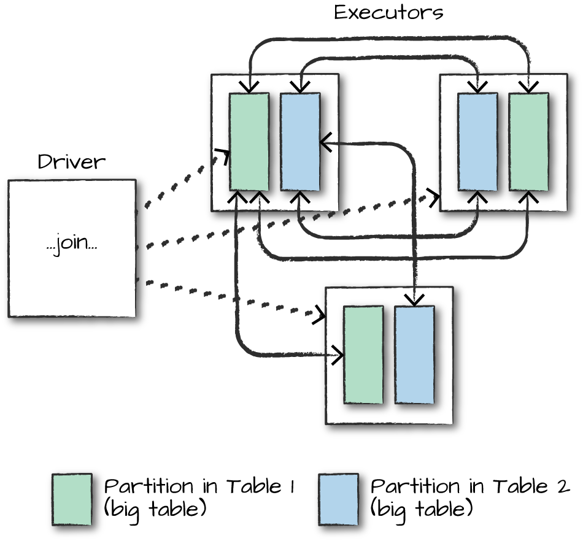

*Figure 8-1. Joining two big tables*

In a shuffle join, every node talks to every other node and they share data according to which node has a certain key or set of keys (on which you are joining). These joins are expensive because the network can become congested with traffic, especially if your data is not partitioned well.

This join describes taking a big table of data and joining it to another big table of data. An example of this might be a company that receives billions of messages every day from the Internet of Things, and needs to identify the day-over-day changes that have occurred. The way to do this is by joining on deviceId, messageType, and date in one column, and date - 1 day in the other column.

In Figure 8-1, DataFrame 1 and DataFrame 2 are both large DataFrames. This means that all worker nodes (and potentially every partition) will need to communicate with one another during the *entire* join process (with no intelligent partitioning of data).

**BIG TABLE–TO–SMALL TABLE**

When the table is small enough to fit into the memory of a single worker node, with some breathing room of course, we can optimize our join. Although we can use a big table–to–big table communication strategy, it can often be more efficient to use a broadcast join. What this means is that we will replicate our small DataFrame onto every worker node in the cluster (be it located on one machine or many). Now this sounds expensive. However, what this does is prevent us from performing the all-to-all communication during the *entire* join process. Instead, we perform it only once at the beginning and then let each individual worker node perform the work without having to wait or communicate with any other worker node, as is depicted in Figure 8-2.

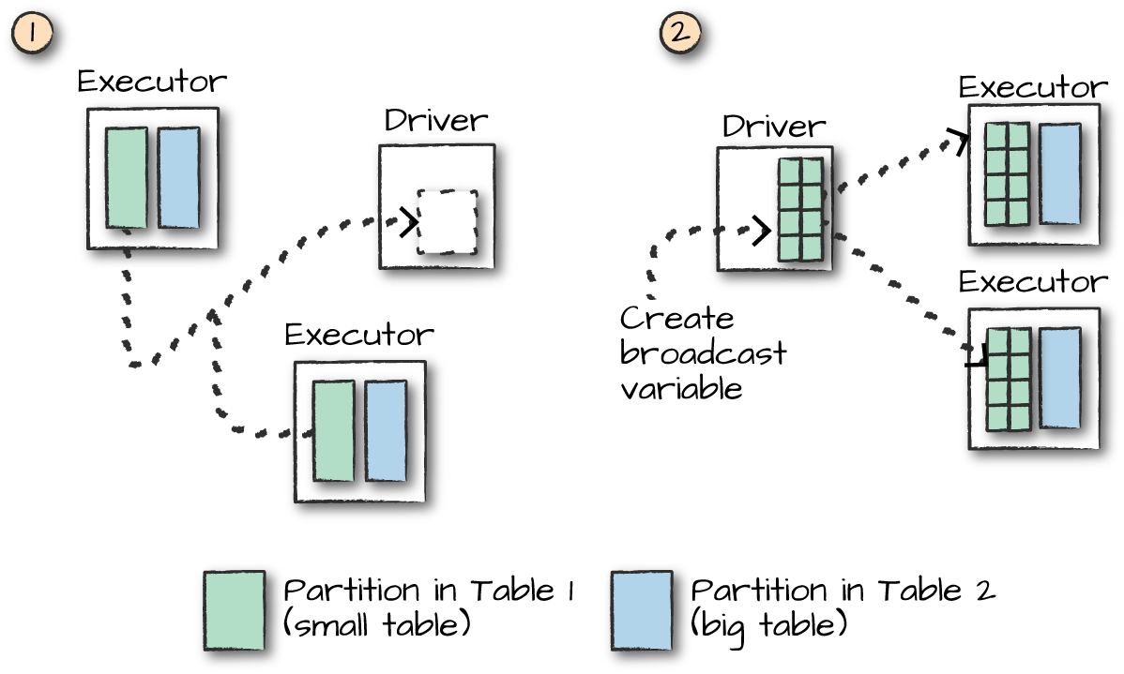

*Figure 8-2. A broadcast join*

At the beginning of this join will be a large communication, just like in the previous type of join. However, immediately after that first, there will be no further communication between nodes. This means that joins will be performed on every single node individually, making CPU the biggest bottleneck. For our current set of data, we can see that Spark has automatically set this up as a broadcast join by looking at the explain plan:

**val** joinExpr **=** person.col("graduate_program") === graduateProgram.col("id")

person.join(graduateProgram, joinExpr).explain()

== Physical Plan ==

*BroadcastHashJoin [graduate_program#40], [id#5....

:- LocalTableScan [id#38, name#39, graduate_progr...

+- BroadcastExchange HashedRelationBroadcastMode(....

+- LocalTableScan [id#56, degree#57, departmen....

With the DataFrame API, we can also explicitly give the optimizer a hint that we would like to use a broadcast join by using the correct function around the small DataFrame in question. In this example, these result in the same plan we just saw; however, this is not always the case:

**import** **org.apache.spark.sql.functions.broadcast**

**val** joinExpr **=** person.col("graduate_program") === graduateProgram.col("id")

person.join(broadcast(graduateProgram), joinExpr).explain()

The SQL interface also includes the ability to provide *hints* to perform joins. These are not *enforced*, however, so the optimizer might choose to ignore them. You can set one of these hints by using a special comment syntax. MAPJOIN, BROADCAST, and BROADCASTJOIN all do the same thing and are all supported:

*-- in SQL*

**SELECT** */*+ MAPJOIN(graduateProgram) */* * **FROM** person **JOIN** graduateProgram

**ON** person.graduate_program = graduateProgram.id

This doesn’t come for free either: if you try to broadcast something too large, you can crash your driver node (because that collect is expensive). This is likely an area for optimization in the future.

**LITTLE TABLE–TO–LITTLE TABLE**

When performing joins with small tables, it’s usually best to let Spark decide how to join them. You can always force a broadcast join if you’re noticing strange behavior.

**Conclusion**

In this chapter, we discussed joins, probably one of the most common use cases. One thing we did not mention but is important to consider is if you partition your data correctly *prior to a join*, you can end up with much more efficient execution because even if a shuffle is planned, if data from two different DataFrames is already located on the same machine, Spark can avoid the shuffle. Experiment with some of your data and try partitioning beforehand to see if you can notice the increase in speed when performing those joins. In [Chapter 9](https://www.safaribooksonline.com/library/view/spark-the-definitive/9781491912201/ch09.html#s2c6---data-sources), we will discuss Spark’s data source APIs. There are additional implications when you decide what order joins should occur in. Because some joins act as filters, this can be a low-hanging improvement in your workloads, as you are guaranteed to reduce data exchanged over the network.

The next chapter will depart from user manipulation, as we’ve seen in the last several chapters, and touch on reading and writing data using the Structured APIs.